Project Mastery Assignment
Reflection Log
Stefan S
CSE 2140 2nd Language Programming
(Digits2.java)
How has your program changed from planning to coding to now? Explain.
First working version of the assignment: (See the error log to see how I got here)
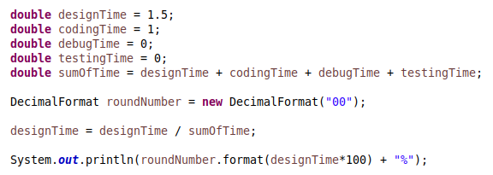

From this point on, I realized that I was repeating lines a lot and could make my code better by using a dictionary (called a Map in Java; a dictionary is a thing in java, but it’s outdated.) rather than individual variables.
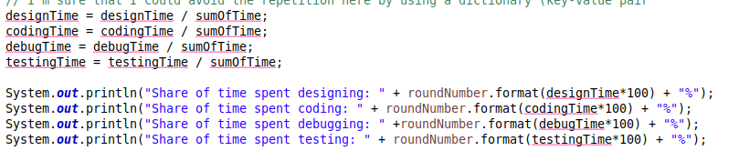
(ignore the red lines; I took this screenshot a little late.)

First working version of the program to use a dictionary (HashMap). I was adding the scanner text at the time I took the screenshot. The percentages are also not correct at this point, I still need to do the division and multiplication.
